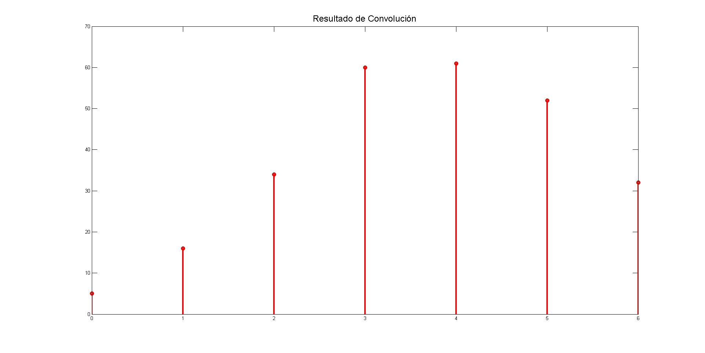

**Luis Fernando Zarazua Aguilar 2MV1 ASYS**

x1(n)=[1,2,3,4] x2(n)=[5,6,7,8] C(n)= [5,16,34,60,61,52,32]

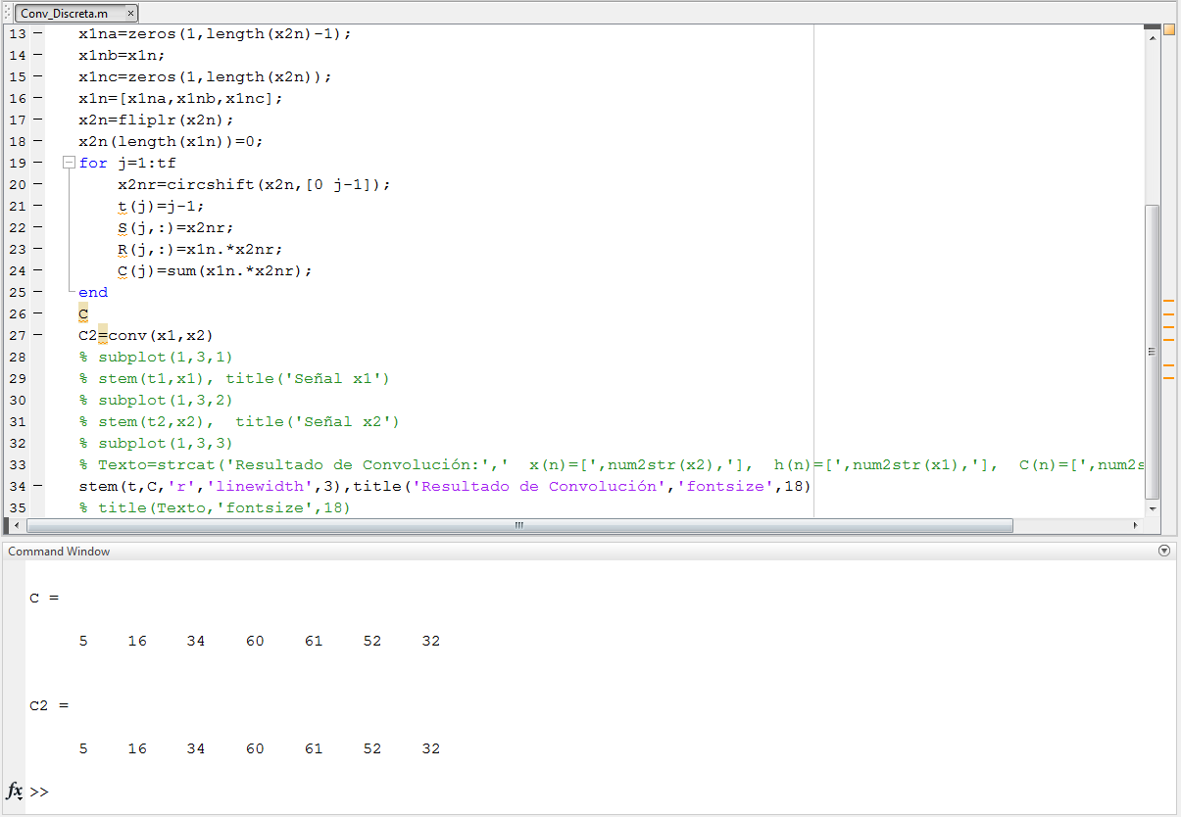

clc

clear all

close all

x1n=[1 2 3 4];

x2n=[5 6 7 8];

x1=x1n;

x2=x2n;

t1=0:1:length(x1)-1;

t2=0:1:length(x2)-1;

tf=length(x1n)+length(x2n)-1;

x1na=zeros(1,length(x2n)-1);

x1nb=x1n;

x1nc=zeros(1,length(x2n));

x1n=[x1na,x1nb,x1nc];

x2n=fliplr(x2n);

x2n(length(x1n))=0;

for j=1:tf

x2nr=circshift(x2n,[0 j-1]);

t(j)=j-1;

S(j,:)=x2nr;

R(j,:)=x1n.*x2nr;

C(j)=sum(x1n.*x2nr);

end

C

C2=conv(x1,x2)

stem(t,C,'r','linewidth',3),title('Resultado de Convolución','fontsize',18)